**Employement Provided Pattern**

**(1) Employement Provided Pattern in HouseHolds**

**Inference:**

* Wayanad district experiences seasonal variations in household counts, possibly influenced by migration patterns, tourism, or agricultural activities.
* Kalpetta block might be more populous or have higher residential density compared to other blocks.
* September and November could be months of increased activity or population influx in the district, possibly due to seasonal employment opportunities or cultural events.
* Sultan Bathery block generally has lower household counts compared to other blocks.
* There seems to be a slight decrease in household counts towards the end of the year, from November to March.

**Inferences:**

* Kalpetta and Mananthavady blocks experience significant increases in household counts from April to May, while Panamaram and Sultan Bathery show relatively smaller increases during the same period
* Kalpetta remains the most populous block in Wayanad district, followed by Mananthavady, Panamaram, and Sultan Bathery.
* The months of September and November seem to be critical in terms of household counts, suggesting potential seasonal or cultural factors influencing population movements or activities during this period.

**Inference:**

* Kalpetta block still maintains a consistently higher number of households throughout the year, followed by Mananthavady, Panamaram, and Sultan Bathery.
* October and November continue to show peaks in household counts across all blocks, with Kalpetta having the highest increase during May.
* Sultan Bathery block consistently has a lower number of households compared to other blocks.
* There's a general trend of fluctuations in household counts throughout the year, with peaks observed during October and November..
* Sultan Bathery block shows a notable increase in household counts from April to May, while other blocks also experience increases during this period.

**(2) Employement Provided Pattern in PersonDays**

**Inferences:**

* Mananthavadi remains the block with the highest number of person-days, suggesting higher activity levels or population density in this area.
* June stands out as a critical month for person-days, indicating potential peak seasons for various activities such as tourism, agriculture, or cultural events.
* Understanding these trends can assist local authorities in planning and implementing targeted interventions to address various socio-economic
* The months from November to March generally exhibit a decrease in person-days across all block

**Inference**

* Kalpetta remains the block with the highest number of person-days, suggesting higher activity levels or population density in this area.
* June stands out as a critical month for person-days, indicating potential peak seasons for various activities such as tourism, agriculture, or cultural events.
* Sultan Bathery block consistently exhibits a lower number of person-days compared to other blocks throughout the year.
* The months from November to March generally exhibit a decrease in person-days across all blocks.

**Inference**

* Kalpetta remains the block with the highest number of person-days, suggesting higher activity levels or population density in this area.
* June continues to be a crucial month for person-days, indicating potential peak seasons for various activities such as tourism, agriculture, or cultural events.

**(3) Employment Provided Pattern to Household in Kalpetta**

* There is a consistent increase in employment provided from April to June.
* June has the highest employment provided during this financial year, indicating a peak period.
* There's a gradual decrease in employment from July onwards, with lower numbers towards the end of the financial year.
* Similar to the previous year, there is a noticeable increase in employment provided from April to June.
* June remains the month with the highest employment provided.
* There's a gradual decline in employment from July onwards, although the decline seems more pronounced compared to the previous year.
* The trend of increasing employment from April to June continues.
* However, there's a significant decrease in employment provided in June compared to the previous two financial years.
* Employment numbers fluctuate throughout the rest of the financial year, with varying levels of provided employment each month.

Tables:

Employement Provided Pattern During Financial Year : 2021-2022

Month wise household

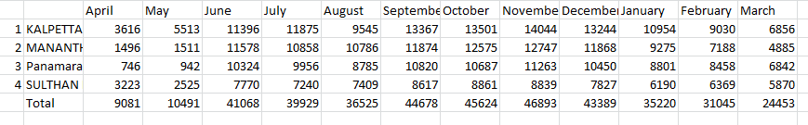

Employement Provided Pattern During Financial Year : 2022-2023

Month wise household

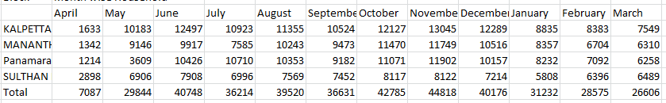

Employement Provided Pattern During Financial Year : 2023-2024

Month wise household

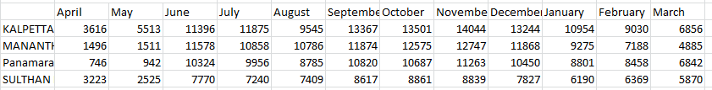

Employement Provided Pattern During Financial Year : 2021-2022

Month wise Persondays

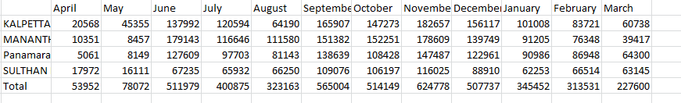

Employement Provided Pattern During Financial Year : 2022-2023

Month wise Persondays

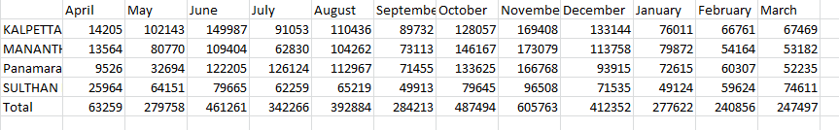

Employement Provided Pattern During Financial Year : 2022-2023

Month wise Persondays

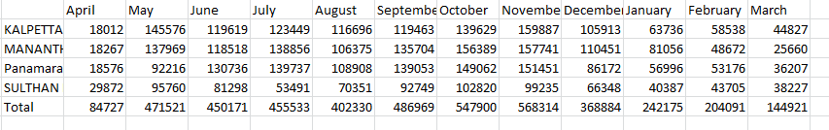

**Employment in Wayanad**

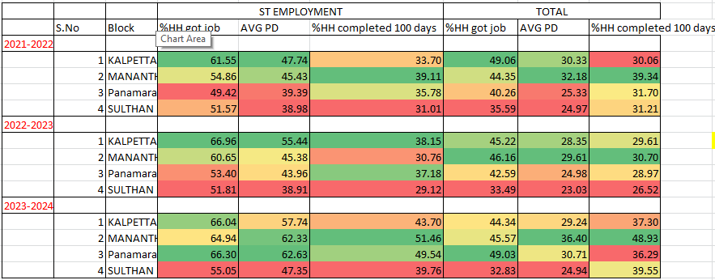

**ST Employment in Wayand**

Over the span of three years, there's a general upward trend in the percentage of households in each block in ST employment, with Panamaram showing the most notable improvement, increasing from 49.42% in 2021-2022 to 66.30% in 2023-2024. Kalpetta and Mananthavady also experienced increases, albeit with minor fluctuations, while Sulthan Bathery's percentage remained relatively stable, showing a slight rise from 51.57% to 55.05% over the same period.

Over the three years, there's a consistent increase in the average number of persons per day engaged in ST employment across all blocks, with the most significant rise observed in Mananthavady, escalating from 45.43 in 2021-2022 to 62.33 in 2023-2024. Panamaram also exhibits substantial growth, with the average number of persons per day increasing from 39.39 to 62.63 over the same period. Kalpetta shows a steady increase, while Sulthan Bathery experiences fluctuations, ultimately increasing from 38.98 to 47.35 persons per day.

Over the three years, there's a general trend of increasing percentages of households completing 100 days of work among those provided with ST employment in all blocks. Mananthavady consistently shows the highest rates, rising from 39.11% in 2021-2022 to 51.46% in 2023-2024. Panamaram and Kalpetta also exhibit noticeable increases, while Sulthan Bathery shows a comparatively smaller rise, with fluctuations over the years, reaching 39.76% in 2023-2024.

**Total Employment in Wayanad**

Over the three years, there's a varied trend in the percentage of households getting jobs (HH) across blocks. Mananthavady shows relative stability, with percentages fluctuating slightly around the mid-40s, while Kalpetta and Panamaram experience slight decreases from 2021-2022 to 2023-2024. Sulthan Bathery sees a more pronounced decrease in the percentage of households getting jobs over the same period, dropping from 35.59% to 32.83%.

**T**he provided data on the average number of total workers per day across different blocks over three years reveals varying trends. Mananthavady experienced a notable increase in total workers per day, indicating potential growth or increased demand for labor in that area. Panamaram also saw an increase in total workers per day, suggesting a similar trend of growth or demand. However, Kalpetta and Sulthan Bathery showed fluctuations with slight decreases in total workers per day, which could reflect shifts in economic activity or employment opportunities in those regions.

The data indicates fluctuating rates of households completing 100 days of employment across the studied blocks over the three years. Mananthavady demonstrates a consistent increase in the percentage of households completing 100 days, potentially suggesting improved job stability or engagement in the area. Kalpetta shows variability, with a notable increase in the final year, possibly indicating fluctuations in employment opportunities. Panamaram and Sulthan Bathery display mixed trends with fluctuations, implying varying levels of employment stability or engagement over the period.

1. **Employement in Kalpetta**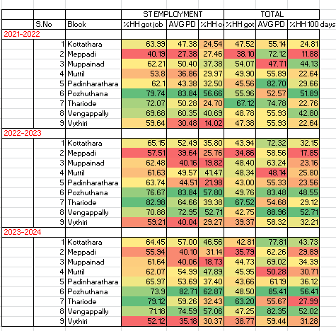

**(1.1)ST Employment in Kalpetta**

The data shows varying levels of participation in the ST employment scheme across different blocks in Kalpetta over the years, with some blocks consistently maintaining high percentages of households securing jobs, such as Pozhuthana and Thariode, while others exhibit fluctuations. Overall, there is a general trend of participation in ST employment across the region, indicating ongoing efforts to provide employment opportunities to households.

The average number of persons per day (AVG PD) engaged in ST employment in Kalpetta's various blocks demonstrates considerable variability, with blocks like Pozhuthana consistently having high engagement, while others like Meppadi and Vythiri exhibit lower levels of participation over the years 2021-2022 to 2023-2024.

There's notable variability in completion rates across blocks, with Pozhuthana consistently maintaining relatively high completion percentages, while other blocks like Vythiri and Thariode show lower rates, though some blocks demonstrate fluctuations over the three years.

**(1.2)Total Employment in Kalpetta**

The employment rates across various blocks in the region have fluctuated slightly over the past three years, with Thariode consistently having the highest percentage of households securing jobs, while Meppadi and Vythiri have shown lower rates comparatively.

Over the span of three years, there has been a general trend of slight decline in the percentage of households securing jobs across most blocks, with Thariode consistently maintaining the highest employment rate, while Meppadi and Vythiri have shown relatively lower rates compared to others.

Over the three-year period, there's been a consistent increase in the percentage of households completing 100 days of work across most blocks, with Pozhuthana consistently showing the highest rates. Thariode, however, displayed a slight decline in the completion rates over this period.

Top of Form

1. **Employement in Mananthavady**

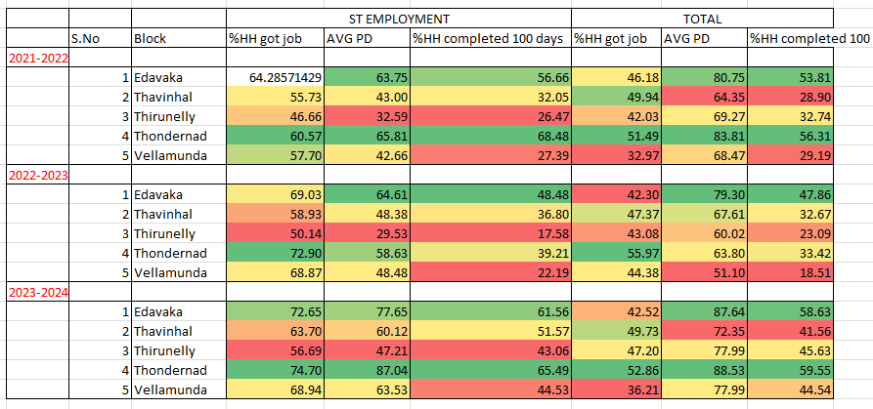

**(2.1)ST Employment in Mananthavady**

Over the three-year period, there's been a consistent upward trend in the percentage of households securing jobs in each block, with Thondernad consistently exhibiting the highest employment rates. Edavaka also showed notable improvement in job acquisition rates, while Thirunelly had relatively lower but still increasing rates.

Over the three-year period, there has been a significant fluctuation in the average number of person-days (PD) of work generated per household in each block. Thondernad consistently exhibited the highest average PD, with a notable increase over the years, while Thirunelly showed relatively lower averages but demonstrated an increasing trend.

Over the three-year period, there's been a noticeable fluctuation in the percentage of households completing 100 days of work across different blocks. Thondernad consistently showed relatively higher completion rates, while Thirunelly had lower rates but demonstrated an increasing trend over the years.

**(2.2)Total Employment in Mananthavady**

Over the three-year period, the percentage of households securing jobs fluctuated across different blocks, with Thondernad consistently showing relatively higher rates compared to others. Edavaka and Vellamunda exhibited lower rates, with some fluctuations over the years, while Thirunelly and Thavinhal maintained relatively stable employment rates.

Over the three-year period, there's been a general increase in the average number of person-days (PD) of work generated per household across most blocks, with Thondernad consistently exhibiting the highest average PD. Edavaka and Vellamunda also showed notable increases in average PD over the years, while Thirunelly and Thavinhal had relatively lower but still increasing averages.

Over the three-year period, there's been fluctuation in the percentage of households completing 100 days of work across different blocks. Thondernad consistently showed relatively higher completion rates, while Thirunelly and Thavinhal had lower rates but demonstrated an increasing trend over the years. Edavaka and Vellamunda exhibited fluctuating completion rates with an overall increasing trend.

1. **Employement in Panamaram**

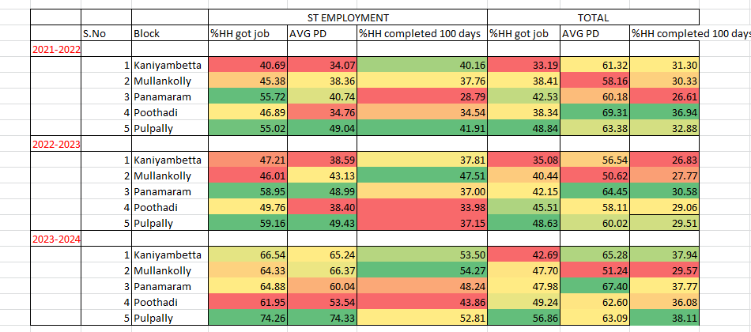

**(3.1)ST Employment in Panamaram**

Over the three-year period, there's been a consistent upward trend in the percentage of households securing jobs across all blocks, with Pulpally exhibiting the highest employment rates consistently. Kaniyambetta showed the most significant improvement in job acquisition rates over the years.

Over the three-year period, there's been a notable increase in the average number of person-days (PD) of work generated per household across all blocks, with Pulpally consistently exhibiting the highest average PD. Kaniyambetta and Mullankolly also showed significant increases in average PD over the years, while Panamaram and Poothadi had comparatively lower but still increasing averages.

Over the three-year period, there's been fluctuation in the percentage of households completing 100 days of work across different blocks, with Mullankolly consistently showing relatively higher completion rates. Pulpally and Kaniyambetta demonstrated an increasing trend in completion rates over the years, while Panamaram and Poothadi had fluctuating completion rates with no clear trends.

**(3.2)Total Employment in Panamaram**

Over the three-year period, there's been a general upward trend in the percentage of households securing jobs across all blocks, with Pulpally consistently exhibiting the highest employment rates. Mullankolly and Panamaram also showed notable increases in job acquisition rates over the years, while Kaniyambetta and Poothadi had comparatively lower but still increasing rates.

Over the three-year period, there's been some variation in the average number of person-days (PD) of work generated per household across different blocks. Poothadi consistently exhibited the highest average PD, while Kaniyambetta and Pulpally showed relatively stable averages. Mullankolly showed some fluctuation, and Panamaram demonstrated an increasing trend in average PD over the years.

Over the three-year period, there's been fluctuation in the percentage of households completing 100 days of work across different blocks, with Poothadi consistently showing relatively higher completion rates. Kaniyambetta and Panamaram demonstrated an increasing trend in completion rates over the years, while Mullankolly and Pulpally had fluctuating completion rates with no clear trend.

(4)**Employement in Sulthan Bathery**

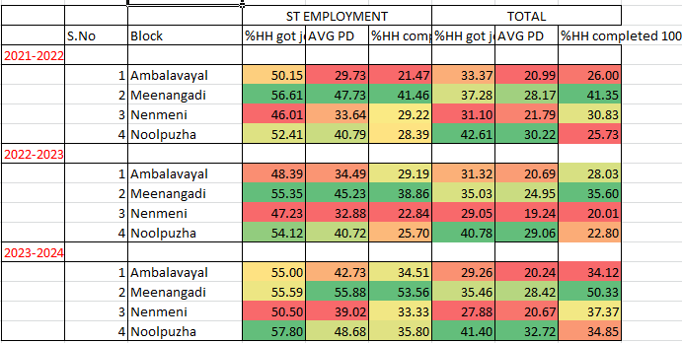

**(4.1)ST Employment in Sulthan Bathery**

The data suggests a generally increasing trend in the percentage of households obtaining jobs across the years 2021 to 2024, with fluctuations observed. Noolpuzha consistently exhibits the highest percentage of households securing employment compared to other blocks, indicating potentially better economic opportunities or job accessibility in that area.

Meenangadi consistently exhibits the highest average percentage of households living in poverty across the years, while Ambalavayal and Nenmeni show increasing trends in poverty rates from 2021-2024. These figures suggest a need for targeted interventions and support in these areas to alleviate poverty and improve living conditions.

Meenangadi consistently shows the highest percentage of households completing 100 days across the years, indicating potentially higher participation rates or better implementation of the program in that block. Ambalavayal and Nenmeni also demonstrate an increasing trend in the percentage of households completing 100 days from 2021-2024, suggesting a possible improvement in program engagement or effectiveness over time.

**(4.2)Total Employment in Sulthan Bathery**

Noolpuzha consistently demonstrates the highest percentage of households obtaining jobs across the years, suggesting potentially better employment opportunities or economic conditions in that block. Conversely, Ambalavayal shows a decreasing trend in the percentage of households getting jobs from 2021-2024, indicating potential challenges or changes in the local job market. Meenangadi and Nenmeni display relatively stable percentages over the years.

Top of Form

Over the three-year period, Noolpuzha consistently had the highest average PersonDays (PD), indicating a higher level of activity or presence compared to Ambalavayal, Meenangadi, and Nenmeni. Meenangadi showed variability in its average PD, while Ambalavayal and Nenmeni exhibited relatively stable trends.

Meenangadi consistently had the highest percentage of households completing 100 days of activity over the three-year period, with a significant increase from 2021-2022 to 2023-2024. Nenmeni showed variability in completion rates, while Ambalavayal and Noolpuzha demonstrated increasing trends over the years

**Average Expenditure**

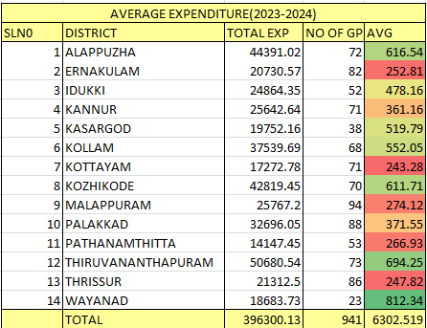

The average expenditure across districts in Kerala for the year 2023-2024 varied considerably, ranging from 243.28 to 812.34 units, with Wayanad district recording the highest average expenditure, while Kottayam district had the lowest average expenditure.

Top of Form 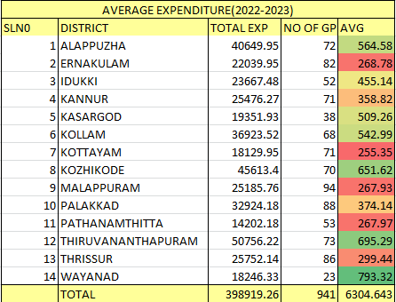

Comparing the average expenditure between 2022-2023 and 2023-2024 in Kerala, there has been some fluctuation with slight increases or decreases across districts. However, overall, the expenditure patterns seem relatively consistent over the two years.

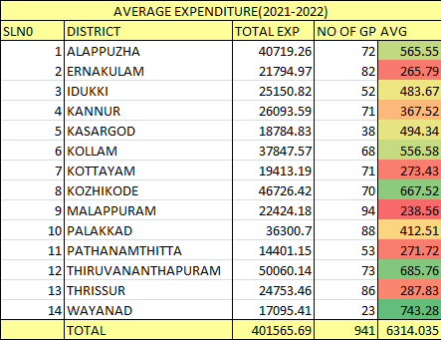

The average expenditure across Kerala districts for the year 2021-2022 varied from 238.56 to 743.28 units, with Palakkad district recording the highest average expenditure and Malappuram district having the lowest average expenditure. Additionally, the total expenditure for all districts combined was 401565.69 units, with an average expenditure of approximately 6314.04 units per gram panchayat.

**AVERAGE PERSON DAYS**

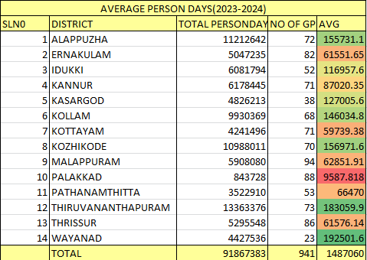

In the year 2023-2024, the average person-days of employment generated per gram panchayat varied significantly across districts in Kerala, ranging from approximately 9587.82 to 183059.95. Wayanad district had the highest average person-days, while Palakkad district had the lowest.

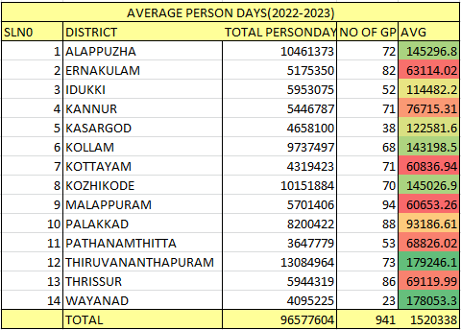

In the year 2022-2023, the average person-days of employment generated per gram panchayat in Kerala ranged from approximately 60836.94 to 179246.08, with Thiruvananthapuram district recording the highest average and Kottayam district having the lowest. There seems to be a considerable variation in employment generation across districts during this period.

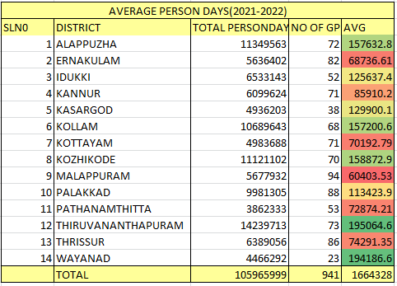

In the year 2021-2022, the average person-days of employment generated per gram panchayat in Kerala ranged from approximately 60403.53 to 195064.56, with Thiruvananthapuram district recording the highest average and Kottayam district having the lowest. There appears to be significant variation in employment generation across districts during this period as well.

**AVERAGE NO OF PEOPLE COMPLETED 100 DAYS**

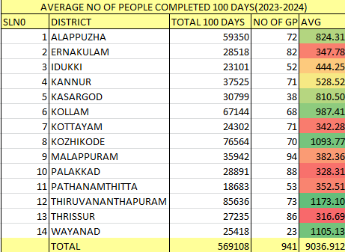

In the year 2023-2024, the average number of people completing 100 days of work per gram panchayat in Kerala ranged from approximately 342.28 to 1173.10, with Thiruvananthapuram district recording the highest average and Kottayam district having the lowest. The total number of people completing 100 days of work across all districts was 569108, with an average of approximately 9036.91 per gram panchayat.

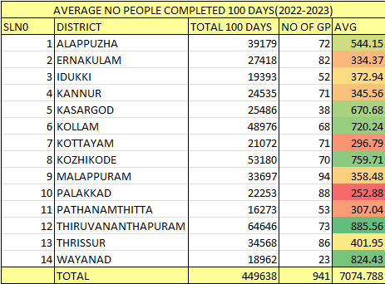

In the year 2022-2023, the average number of people completing 100 days of work per gram panchayat in Kerala ranged from approximately 252.88 to 885.56, with Thiruvananthapuram district recording the highest average and Palakkad district having the lowest. There appears to be a considerable variation in the number of people completing 100 days of work across districts during this period.

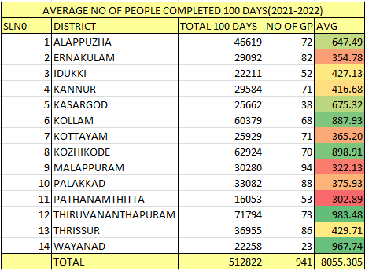

In 2021-2022, the average number of people completing 100 days of work per gram panchayat in Kerala ranged from approximately 302.89 to 983.48, with Thiruvananthapuram district recording the highest average and Pathanamthitta district having the lowest. Overall, across all districts, the average was approximately 8055.31 people completing 100 days of work per gram panchayat.

**AVERAGE HOUSEHOLDS GOT JOB**

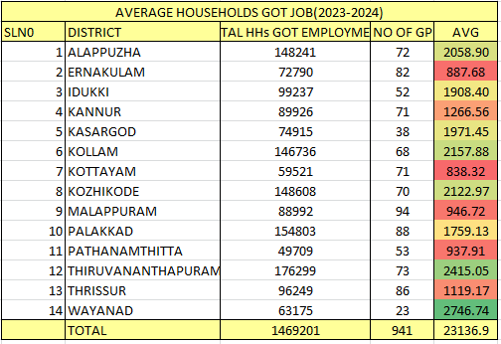

In 2023-2024, the average number of households that got employment per gram panchayat in Kerala ranged from approximately 838.32 to 2746.74, with Wayanad district recording the highest average and Kottayam district having the lowest. There is a notable variation in the number of households that got employment across districts during this period.

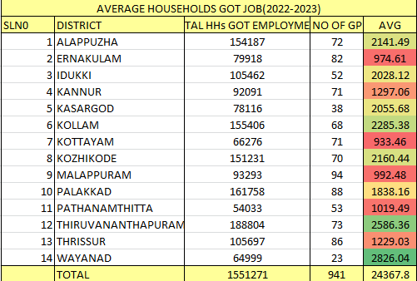

In 2022-2023, the average number of households that got employment per gram panchayat in Kerala ranged from approximately 933.46 to 2826.04, with Wayanad district recording the highest average and Kottayam district having the lowest. This indicates a significant variation in the number of households that got employment across districts during this period.

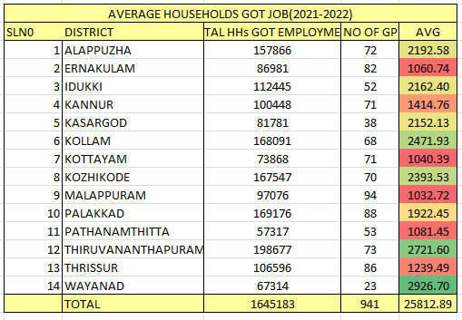

In 2021-2022, the average number of households that got employment per gram panchayat in Kerala ranged from approximately 1040.39 to 2926.70, with Wayanad district recording the highest average and Kottayam district having the lowest. This indicates significant variation in the number of households that got employment across districts during this period.

**AVERAGE ACTIVE JOB CARDS**

|  |  |  |  |  |
| --- | --- | --- | --- | --- |
| AVERAGE ACTIVE JOB CARDS | | | | |
| SLN0 | DISTRICT | ACTIVE JOB | NO OF GP | AVG |
| 1 | ALAPPUZHA | 185412 | 72 | 2575.17 |
| 2 | ERNAKULAM | 119351 | 82 | 1455.50 |
| 3 | IDUKKI | 141807 | 52 | 2727.06 |
| 4 | KANNUR | 135050 | 71 | 1902.11 |
| 5 | KASARGOD | 110249 | 38 | 2901.29 |
| 6 | KOLLAM | 218784 | 68 | 3217.41 |
| 7 | KOTTAYAM | 97246 | 71 | 1369.66 |
| 8 | KOZHIKODE | 208880 | 70 | 2984.00 |
| 9 | MALAPPURAM | 154914 | 94 | 1648.02 |
| 10 | PALAKKAD | 218956 | 88 | 2488.14 |
| 11 | PATHANAMTHITTA | 71874 | 53 | 1356.11 |
| 12 | THIRUVANANTHAPURAM | 242223 | 73 | 3318.12 |
| 13 | THRISSUR | 163766 | 86 | 1904.26 |
| 14 | WAYANAD | 89564 | 23 | 3894.09 |
|  | TOTAL | 2158076 | 941 | 33740.94 |

In terms of active job opportunities in 2023-2024, per gram panchayat, the averages ranged from approximately 1369.66 to 3894.09 across districts in Kerala. Wayanad district had the highest average, while Kottayam had the lowest. This suggests significant variation in active job opportunities across districts during this period.

**AVERAGE ACTIVE WORKERS**

|  |  |  |  |  |
| --- | --- | --- | --- | --- |
| AVERAGE NO OF ACTIVE WORKERS | | | | |
| SLN0 | DISTRICT | ACTIVE WORKERS | NO OF GP | AVG |
| 1 | ALAPPUZHA | 201875 | 72 | 2803.82 |
| 2 | ERNAKULAM | 121368 | 82 | 1480.10 |
| 3 | IDUKKI | 186593 | 52 | 3588.33 |
| 4 | KANNUR | 144858 | 71 | 2040.25 |
| 5 | KASARGOD | 127501 | 38 | 3355.29 |
| 6 | KOLLAM | 233748 | 68 | 3437.47 |
| 7 | KOTTAYAM | 100153 | 71 | 1410.61 |
| 8 | KOZHIKODE | 228712 | 70 | 3267.31 |
| 9 | MALAPPURAM | 165779 | 94 | 1763.61 |
| 10 | PALAKKAD | 234548 | 88 | 2665.32 |
| 11 | PATHANAMTHITTA | 79405 | 53 | 1498.21 |
| 12 | THIRUVANANTHAPURAM | 259651 | 73 | 3556.86 |
| 13 | THRISSUR | 165827 | 86 | 1928.22 |
| 14 | WAYANAD | 107079 | 23 | 4655.61 |
|  | TOTAL | 2357097 | 941 | 37451 |

The average number of active workers per gram panchayat ranged from approximately 1410.61 to 4655.61 across districts in Kerala. Wayanad district had the highest average, while Kottayam had the lowest.

Top of Form

Top of Form

ATop of Form

Top of Form